***Defects are reported based on severity from High to Low.***

1. **Usability Defect**

*Description:*

Password requirements are not clearly defined in error messages. User has to do multiple attempts to figure out password requirements.

*Expected results:*

All length, lower case , upper case, numeric, special characters requirements need to be clearly stated in error message.

Please find below some of error messages:

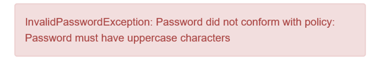

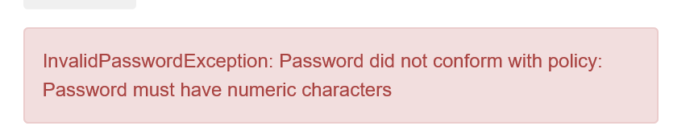

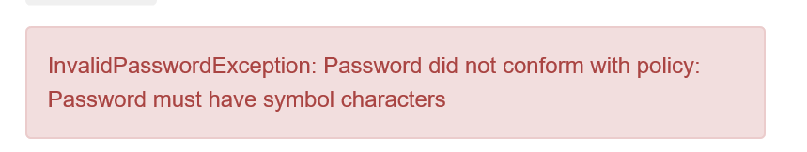

1. **Functionality Defects – Critical severity:**

**Defect1**: “Model” & “Rank” hyperlink clicks are not functioning. There is no event triggered on these clicks.

**Defect2**: click on “Votes” is not sorting the data correctly.

**Steps to reproduce:**

* Navigate to home page
* Click on “Popular Make” image
* Navigate to “popularmake” webpage

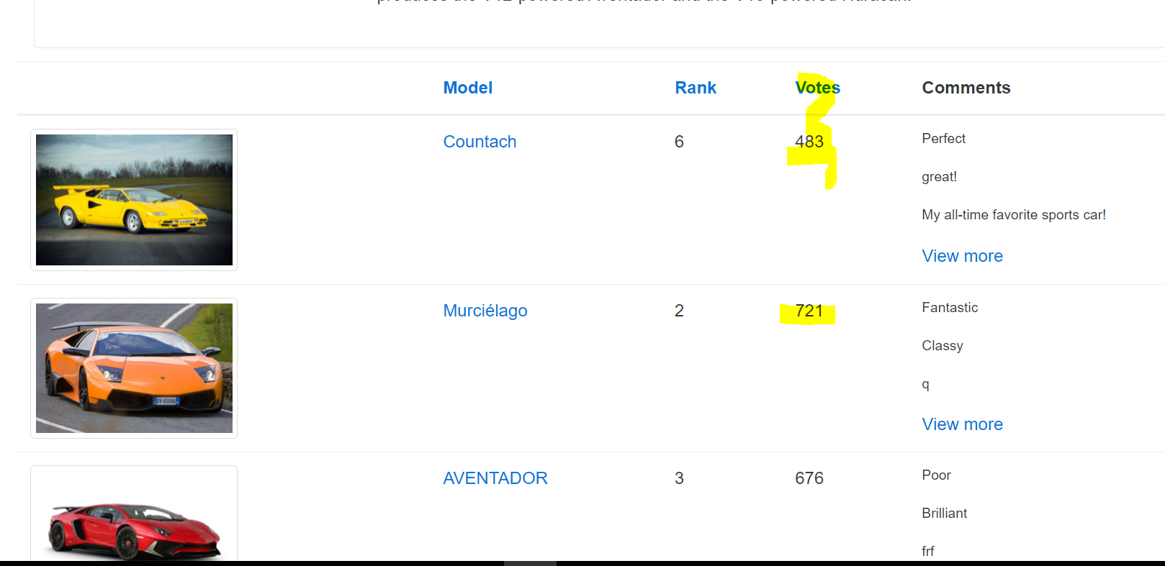

1. **Functionality Defects – Medium severity:**

Steps to reproduce:

* Navigate to home page
* Click on “Overall Rating” image
* Navigate to “overall” webpage
* click on “engine” link to sort on engine range

**Defect1**: Image for “Lancia Ypsilon” model is not displayed.

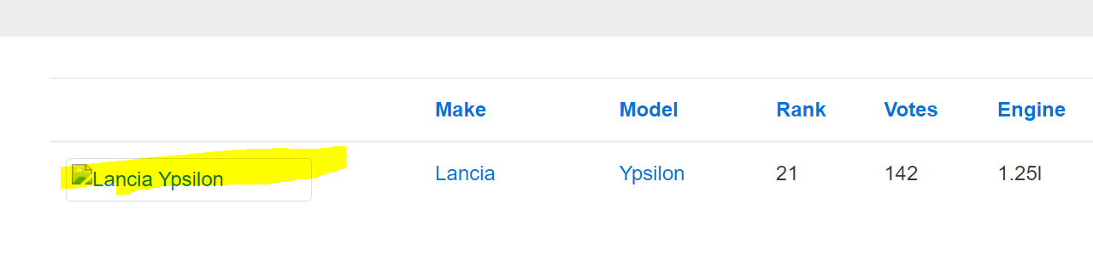

**Defect2**: In overall rating page, sort on “Rank” is not numeric sort, its character sort.

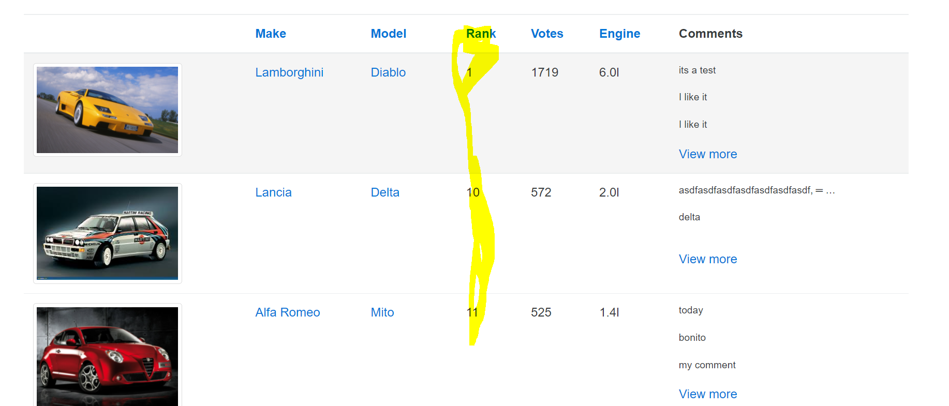

1. **UI Defects – Low severity**

**Defect1**: Register page is still displayed, after initial registration and successful login

